Mego Project

1. Appwrite (backend who will authenticate user,update,delete )

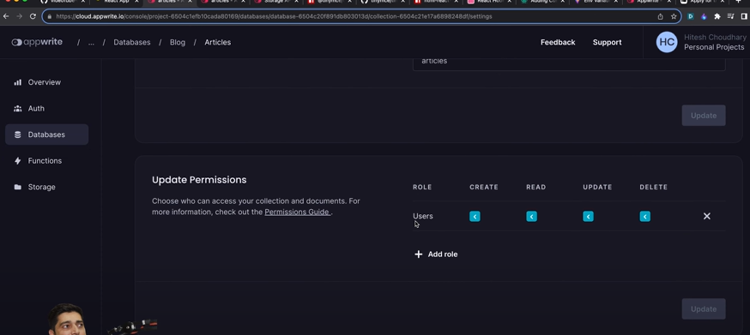

1. Tinymce(text want to bold,italic…)

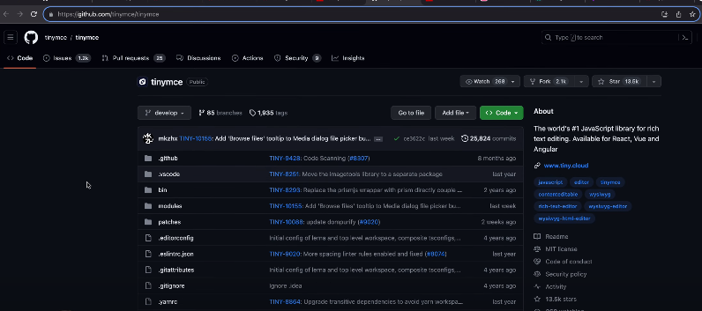

3.html -raect-parser(as we can get html directly so we want html parser)

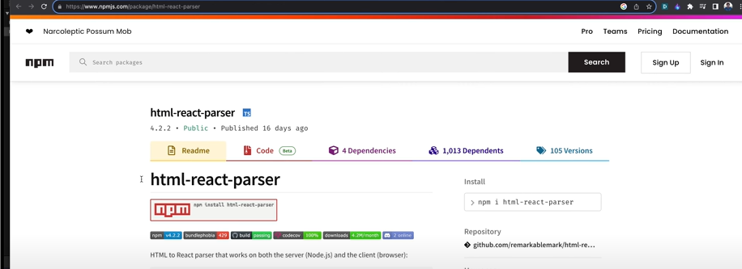

4.React hook Form

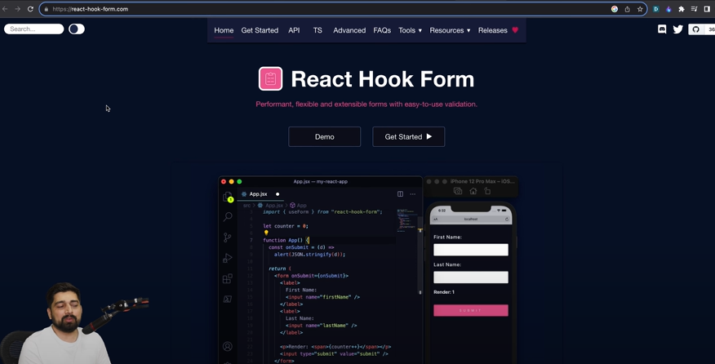

Now create the Project

1. Appwrite

Create database – then craete collection 🡪 then attributes insert

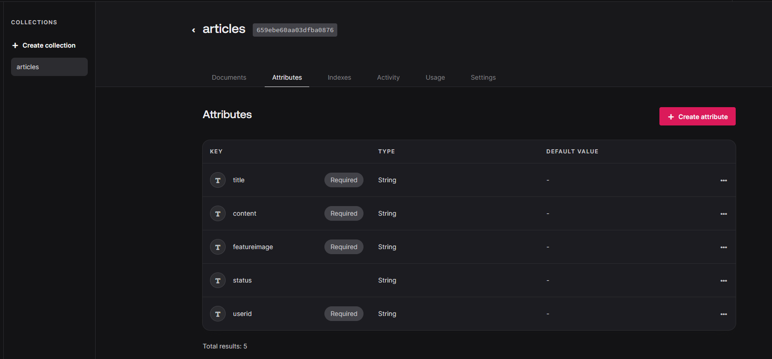

Collection name- articles

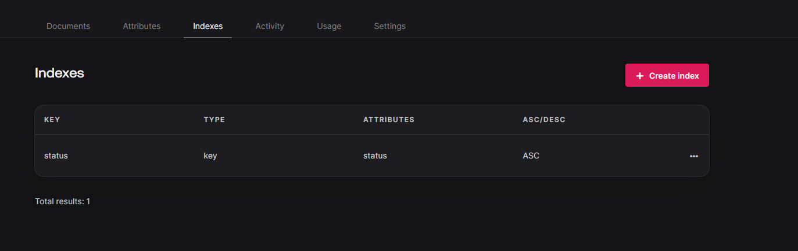

Give indexes and setting have permission

1. 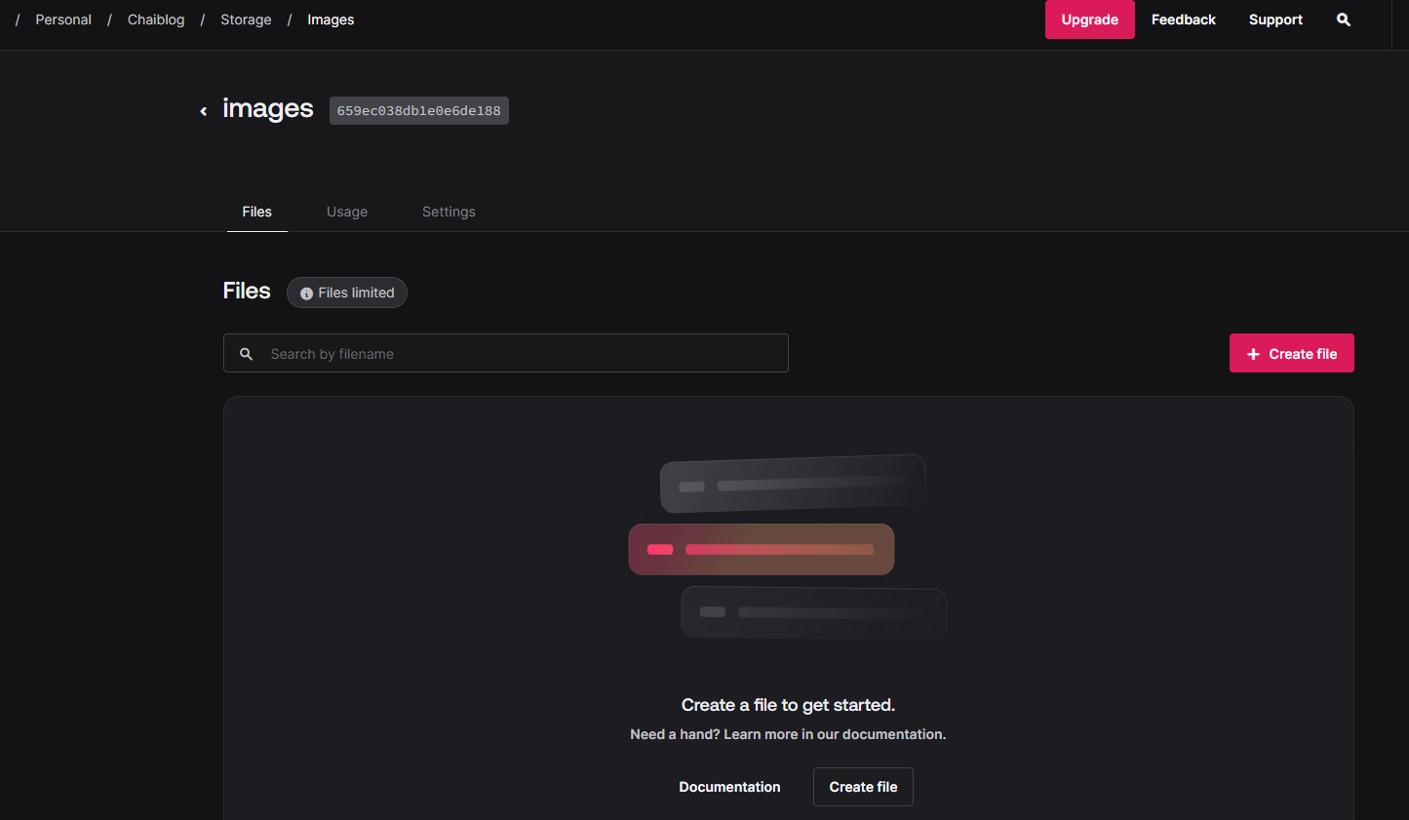

Storage

1. Env done in another file so no console.log()

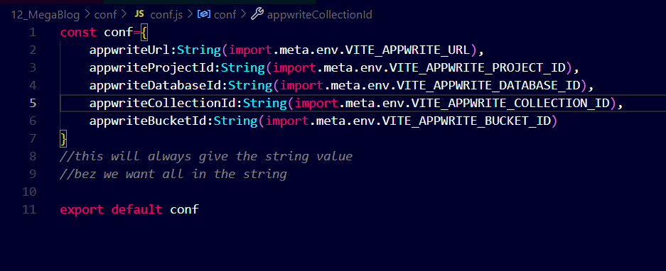

Do this and then use in app.jsx so that string() values will be getten only-🡪

Env varibale always want string()

20th video---------------🡪>>>>>

1st what are the things for the connection -🡪client,Account,ID

Then all the things signup,login,singout wrap in the class

Then make new object of this class and then export that class

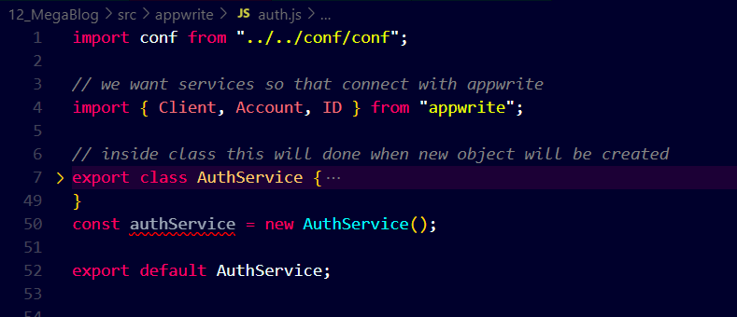

Needed

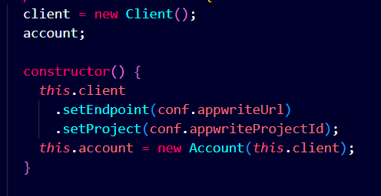

Then create acc🡪

By try and catch take all the things if useracc present then do login else return useracc

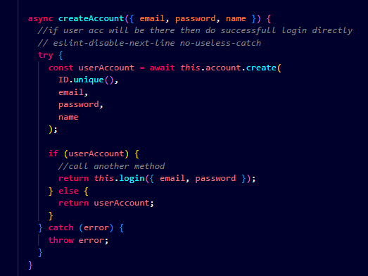

Then login

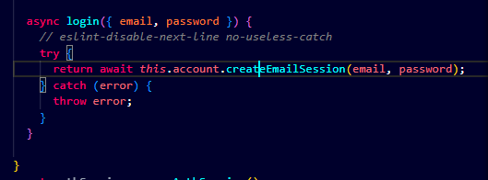

Get current user and logout

Account.get 🡪 give all the session

Session deleted as there are many code and methods are there

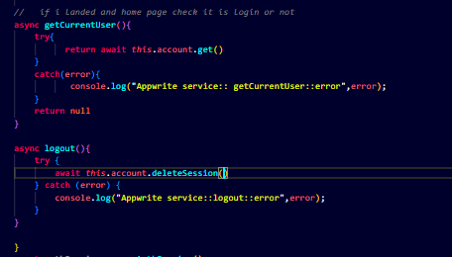

Here in 1st configuration we see:  
authentication,createaccount, login,getcurrentuser,logout

(want url,projectId)

Now we want another services configuration:-- related to post

(url,projectId)

1.createPost -🡪 databaseId, collectionId ,attributes

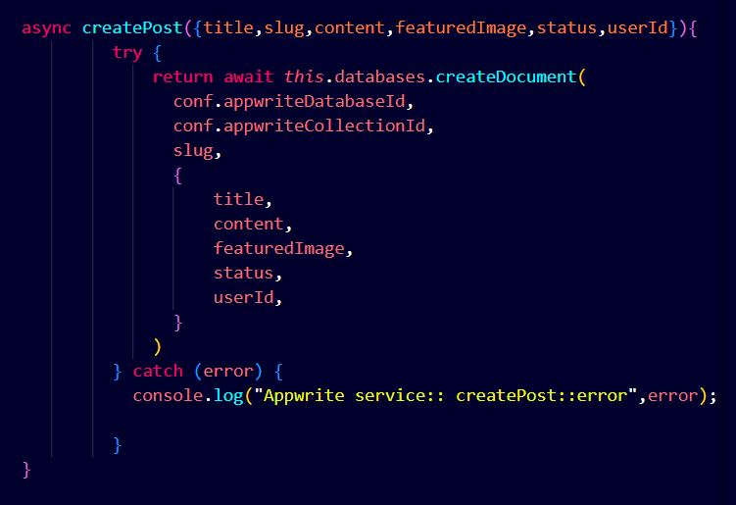

2.Update post --- > here attributes will be updated

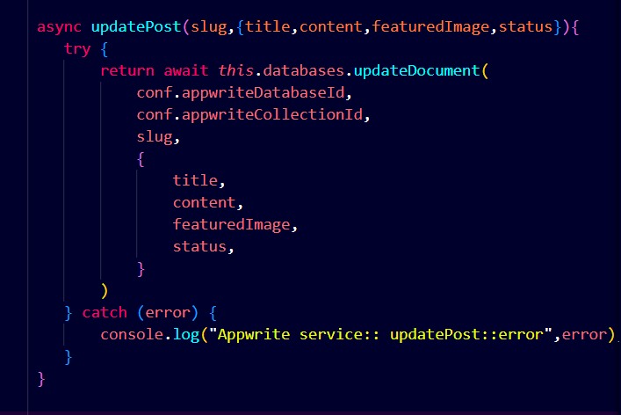

1. Delete post

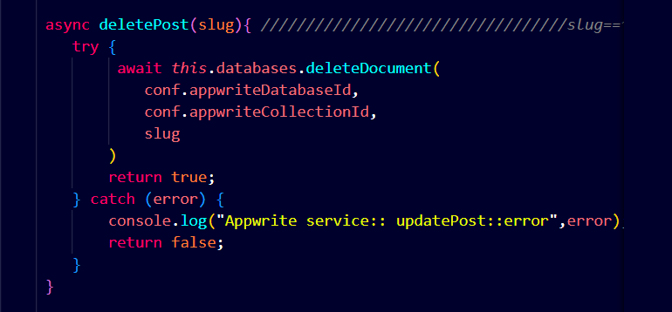

1. Getpost

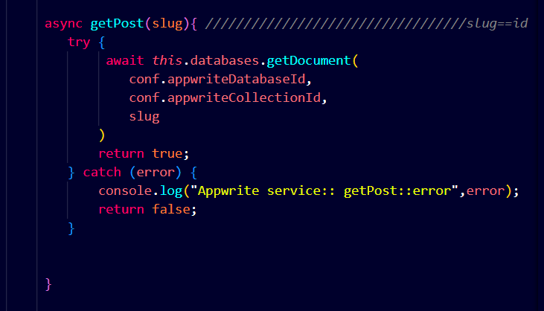

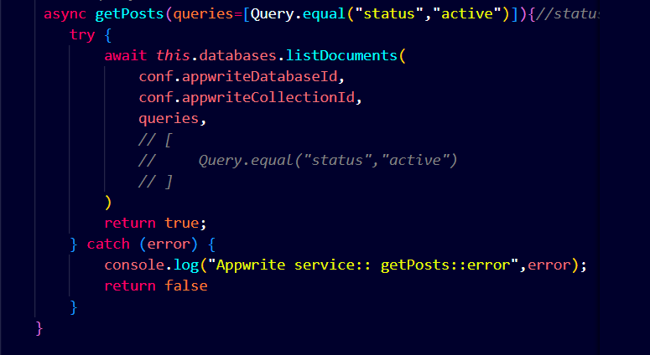

1. Upload file

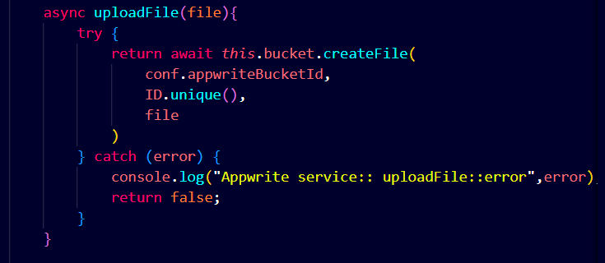

1. Delete file -🡪 get fileId for delete using Bucket

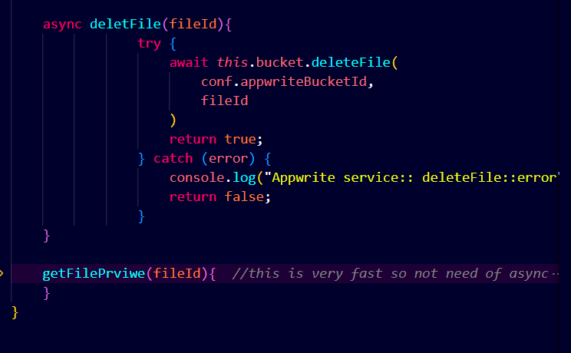

1. getFilePreview

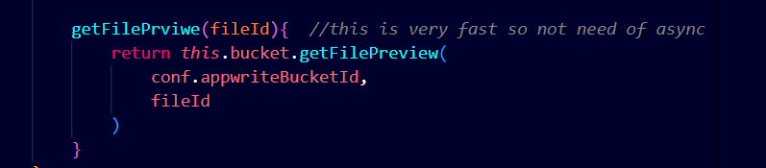

Post update delete get by -🡪 database, collection inside that slag is there where attributes are there and there is post

File-🡪bucketId inside that this will be present with fileId

22🡪

Redux store will be there and we want to config this

Redux have store --- reducer ---dispatch--- selector

1.store

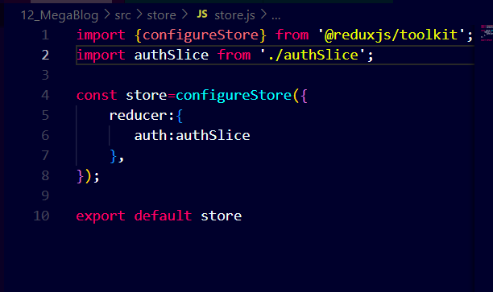

2. reducer

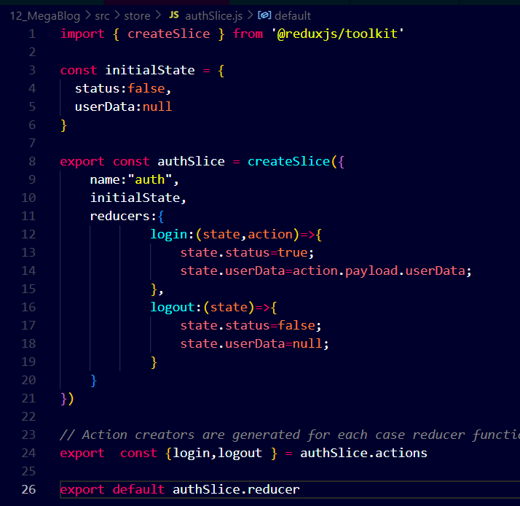

3.give provider

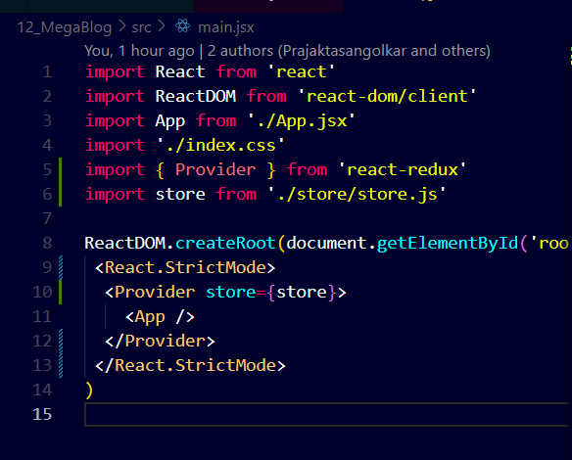

4.App.jsx--- dispatch

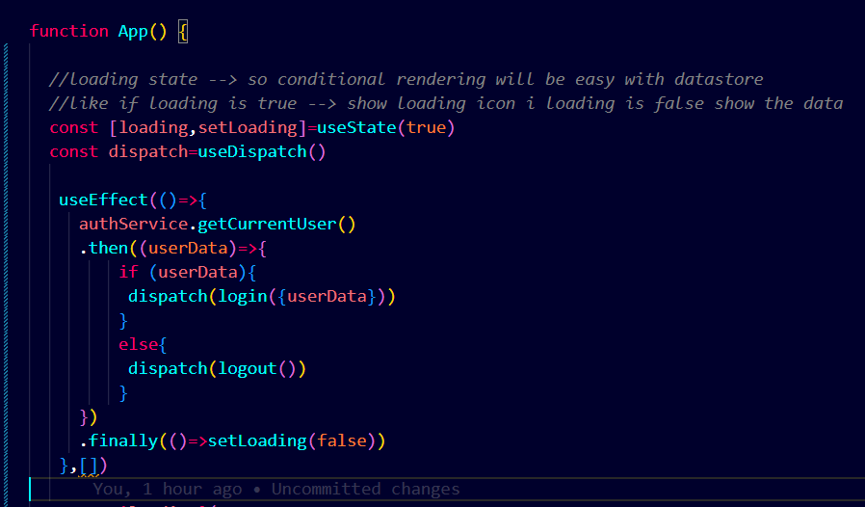

If statement get userData fron getCurrentUser()

If 🡪 data is then do login

Else🡪 logout

Finally 🡪 loading false so go to landing page

Components

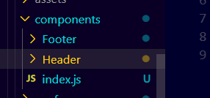

Use this in tha app.jsx

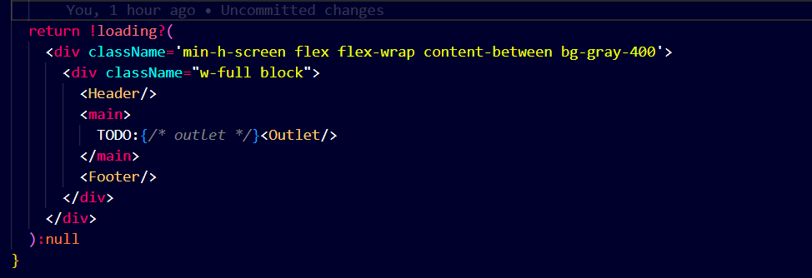

Now 23rd video start:

1. container.jsx -🡪 which have children (not define)
2. Footer🡪 css only
3. LogoutBtn🡪 disptach use and authService of logout then dispatch of logout
4. Index.js

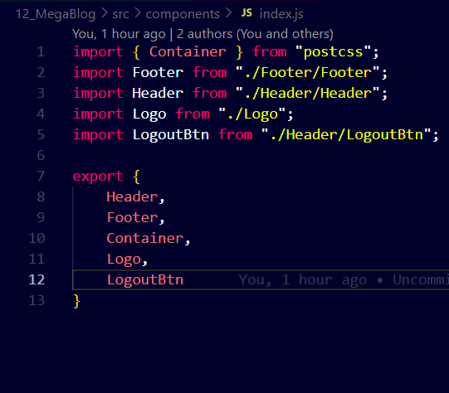

1. Header.jsx

authStatus🡪 find out status using selector

usenavigate() 🡪 for navigation like there is different navItem with active status then navigation show where to go (/addpages,/home)

navItem🡪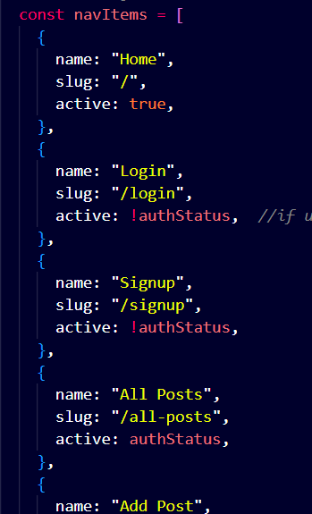

Container 🡪 inside have children

Logo

Ul list ..> if status🡪 active then what pages want to show + if active then show logoutBtn

///////Button -🡪 different way to create button//////

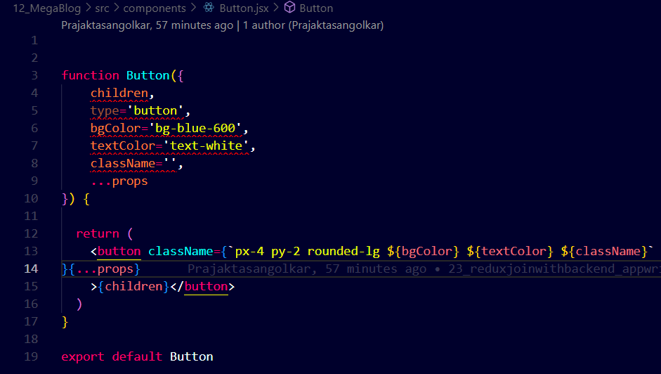

/////////main input.jsx//////////////////////////////////////////

Like there is Login form and we take username,password all

Then we want to connect this to Login page 🡪 so using Forwardref we do this

So how this is done like give input function attr then use

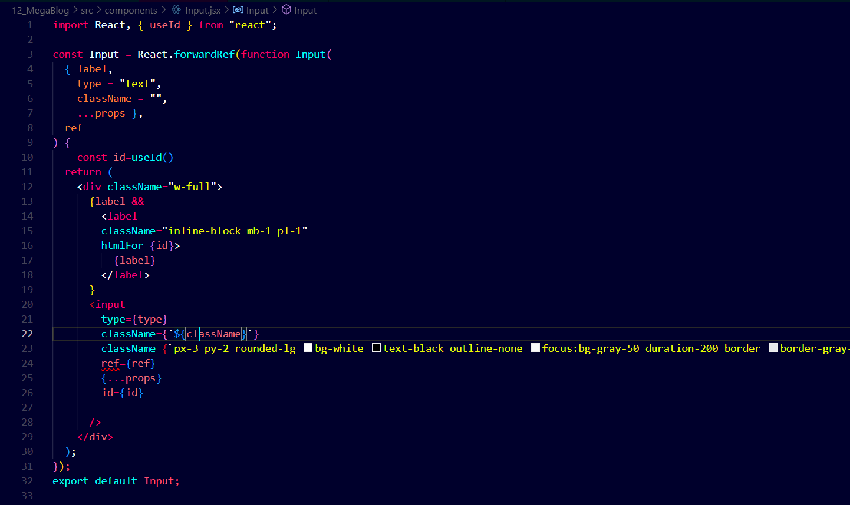

Fron login form take ref , and id which will be used

**24th video :**

1. Select.jsx🡪const id=useId() --🡪 select ref id

Like to many select options and map

1. Input🡪use forwardRef and all and take useId take label and input
2. Postcard-🡪 same as card which is present in home page and after clicking on that card we go to another page of that card

Have link then title and all 🡪 as per id we will get (id will give postcard)🡪 give all the buckets

1. Login 🡪 get by authservice

Get data of login by register and handlesubmit

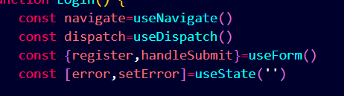

Try catch if login have data -🡪 give current user and navigate to “/”

Show option signin and signup then in signin what input want🡪

Gmail and password with req things and after clicking button it will connect to real login by handleSubmit()

1. Signup--🡪 create an acc with req things and form submit will be go to

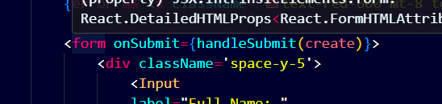

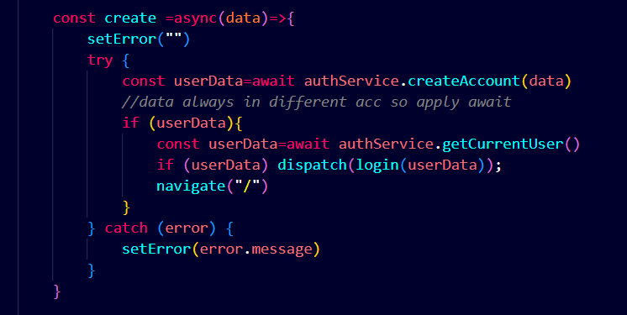

Same as login if signup done then do login and then go to “/” this

1. AuthLayOut

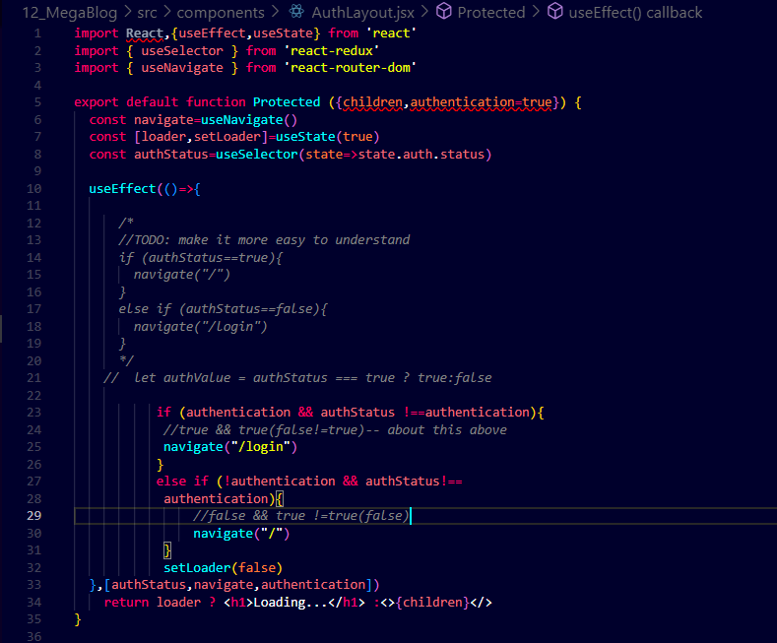

**25th video :**

RTE- real time editor

This is use for editing the form /like post That u want to update or change or create

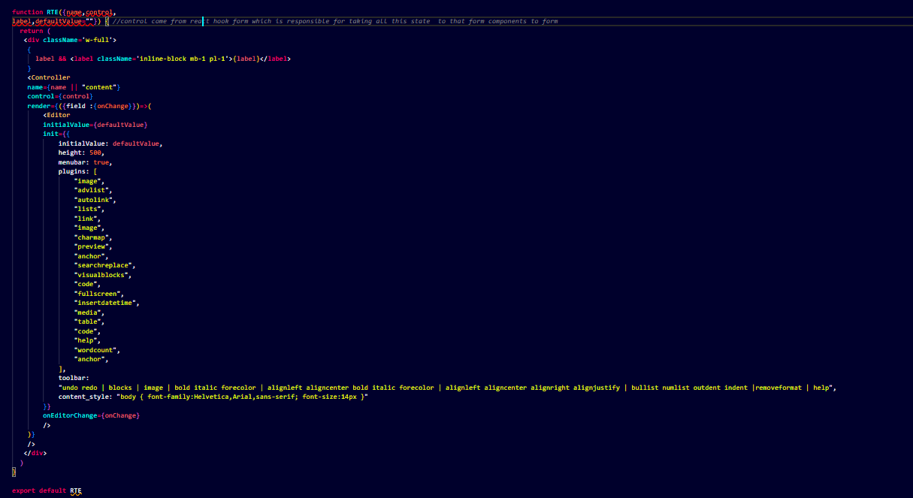

here u can see there is controller for change the text🡪 controller have

name,control,render

<Editor 🡪 initialValue,init🡪 all values ,toolbar,content_style

onEditchange🡪onchange

(all field will be change inside that controller)

2. postForm

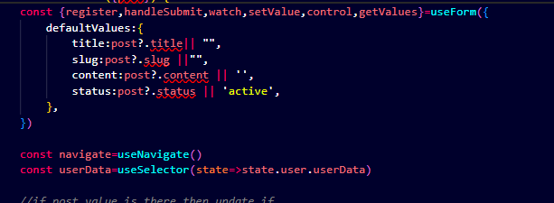

Default values show that if post present then get that title or… else “ ” will be there

Submit --🡪

1. If (post) is there present and u want to change

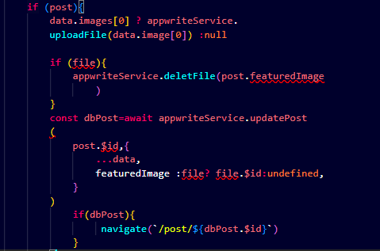

1. Create new post

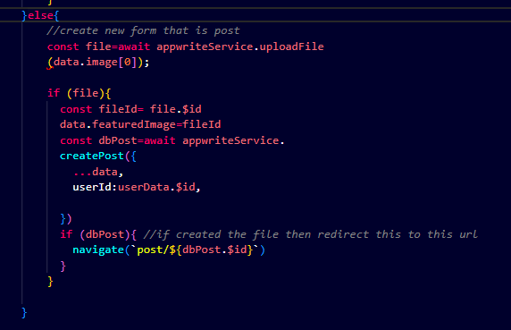

This is for featuredImage

Now for the slug

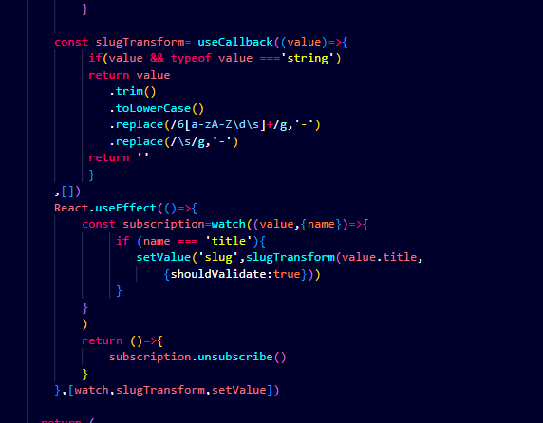

And as useEffect is has been used there so it will take title ans setValue and then do unsubscribed means make it false

This is form/post format

